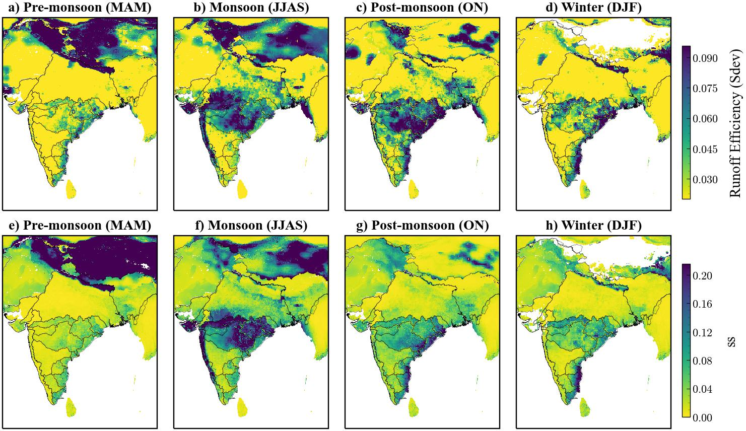

**Fig. S1.** Seasonal standard deviation (Sdev) of runoff efficiency for pre-moonsoon, monsoon, post-monsoon, and winter seasons.

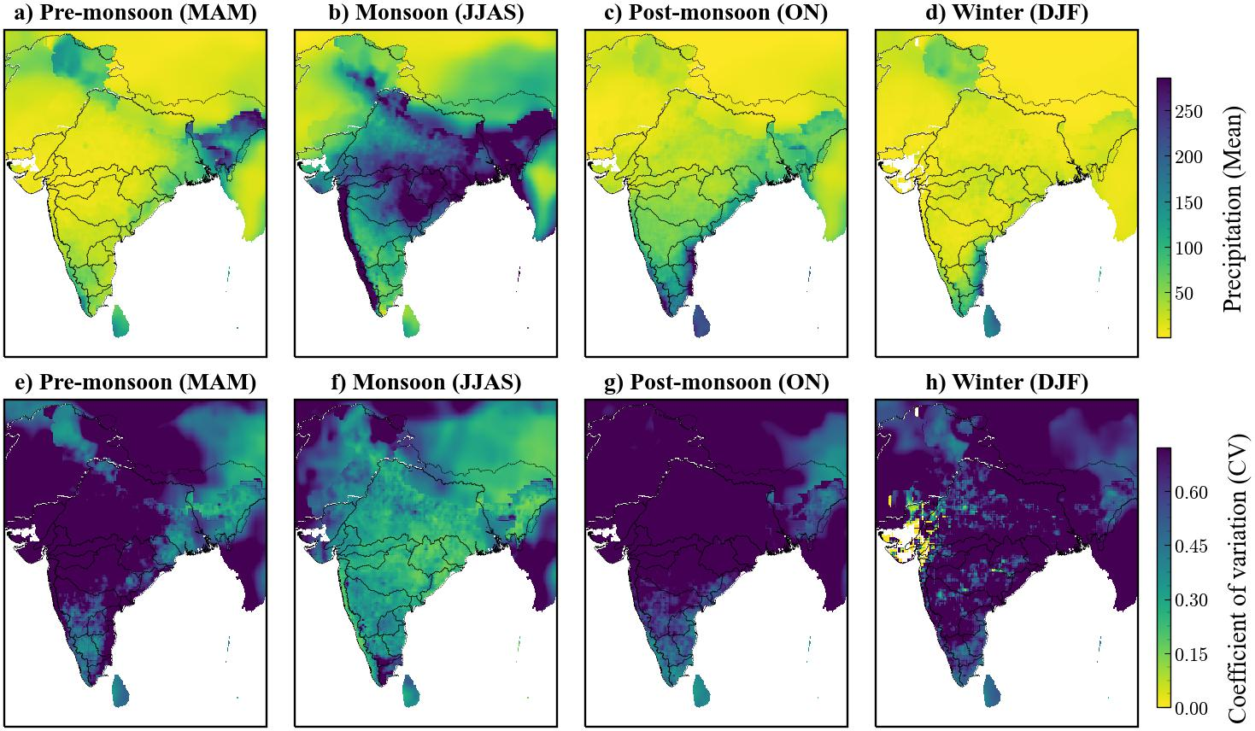

**Fig. S2.** Seasonal mean and variance of precipitation for pre-monsoon, monsoon, post-monsoon, and winter seasons.

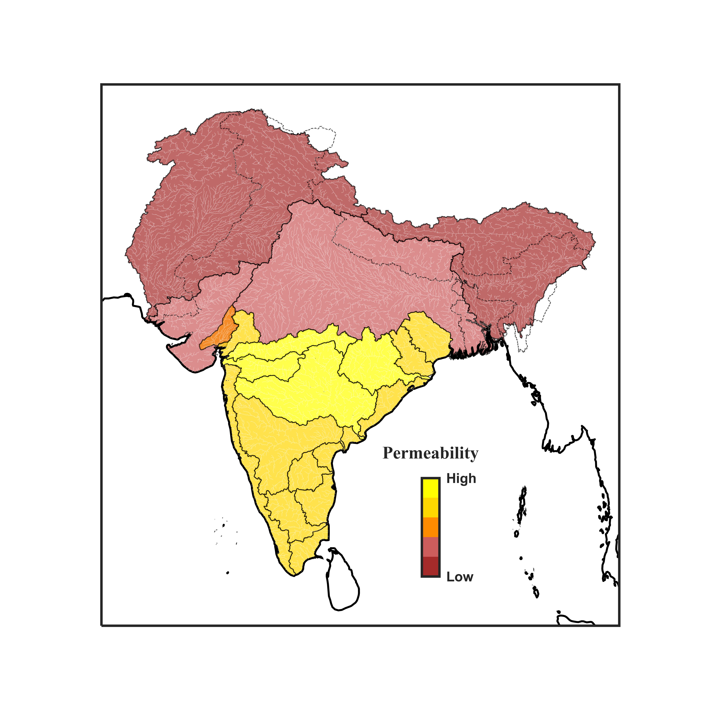

**Fig. S3** Soil Permeability map of South Asia prepared using soil texture and soil group information collected SoilGrids platform of ISRIC (International Soil Reference and Information Centre) (https://soilgrids.org/). Texture classes were prepared as per NRCS (Natural Resources Conservation Service) Soils – USDA soil texture calculator triangle.



**Fig. S4** Composite analysis (El Niño- La Niña) result of the regional average of precipitation, runoff, and runoff efficiency for winter season. ‘*’ shows the regions showing statistically significant differences between El Niño and La Niña events.



**Fig. S5** Trend analysis of runoff efficiency in the pre-monsoon season during 1980-2021 over different basins of India.



**Fig. S6** Trend analysis of runoff efficiency in the post-monsoon season during 1980-2021 over different basins of India.



**Fig. S7** Trend analysis of runoff efficiency in the winter season during 1980-2021 over different basins of India.